Image Model Refactoring

Adam Gu, 2015/8/14

Orientation Info
ImageProcessor keeps two extra copies of the orientation info.

class ImageProcessor {
private:
OrientationInfos orientation_;
OrientationInfos virtual_orientation_;
};

Struct
struct OrientationInfos {
bool bMirror;
bool bRotate90;
int nRotate90;
bool bRotate180;
int nRotate180;
};

Orientation Info (cont.)
DicomImage provides two getters for these orientation info.

Client usage
int ImageBoxBase::GetViewRotation() {
...
imageprocessor::OrientationInfos oi;
image_model_->GetDicomImage()->GetVirtualOrientationInfos(oi);
rotation = 0;
if (oi.bRotate180) {
rotation = 180 * oi.nRotate180;
}
if (oi.bRotate90) {
rotation += oi.nRotate90 * 90;
}
...
}

Orientation Info (cont.)
In order to synchronize with SDK, ImageProcessor has to do really a lot!

Init
bool ImageProcessor::InitProcessingParameters() {
...
orientation_.bMirror = IsAlgoEnabled(PROC_MIRROR);
orientation_.bRotate90 = IsAlgoEnabled(PROC_ROTATE90);
orientation_.bRotate180 = IsAlgoEnabled(PROC_ROTATE180);
orientation_.nRotate90 = orientation_.bRotate90?1:0;
orientation_.nRotate180 = orientation_.bRotate180?1:0;

virtual_orientation_ = orientation_;

return true;
}

Orientation Info (cont.)

Rotate180
bool ImageProcessor::Rotate180Image(bool enabled) {
...
orientation_.nRotate180 = (++orientation_.nRotate180) % 2;
orientation_.bRotate180 = orientation_.nRotate180 > 0;

virtual_orientation_.nRotate180 =
(++virtual_orientation_.nRotate180) % 2;
virtual_orientation_.bRotate180 =
virtual_orientation_.nRotate180 > 0;
}

Orientation Info (cont.)

Rotate90
bool ImageProcessor::Rotate90Image(bool enabled) {
...
orientation_.nRotate90 = (++orientation_.nRotate90)%4;
orientation_.bRotate90 = orientation_.nRotate90>0;

virtual_orientation_.nRotate90 =
(++virtual_orientation_.nRotate90) % 4;
virtual_orientation_.bRotate90 =
virtual_orientation_.nRotate90>0;
}

Orientation Info (cont.)

Mirror
bool ImageProcessor::MirrorImage(bool enabled) {
...
orientation_.bMirror = enabled;
virtual_orientation_.bMirror = enabled;

switch ((orientation_.nRotate90+2*orientation_.nRotate180)%4) {
case 1:
if (enabled) {
virtual_orientation_.nRotate180 =
(++virtual_orientation_.nRotate180)%2;
} else {
virtual_orientation_.nRotate180 = (--virtual_orientation_.nRotate180)%2;

if (virtual_orientation_.nRotate180<0) {
virtual_orientation_.nRotate180 = -virtual_orientation_.nRotate180;
}
}

virtual_orientation_.bRotate180 = virtual_orientation_.nRotate180!=0;
break;

case 3:
if (enabled) {
virtual_orientation_.nRotate180 = (--virtual_orientation_.nRotate180)%2;

if (virtual_orientation_.nRotate180<0) {
virtual_orientation_.nRotate180 = -virtual_orientation_.nRotate180;
}
} else {
virtual_orientation_.nRotate180 = (++virtual_orientation_.nRotate180)%2;
}

virtual_orientation_.bRotate180 = virtual_orientation_.nRotate180!=0;
break;

default:
break;
}

Orientation Info (cont.)
My refactoring removes all these redundant codes!

Client usage
int ImageBoxBase::GetViewRotation() const {
...
int rotation = 0;
if (image_model_->IsRotate180Applied()) {
rotation += 180;
}
if (image_model_->IsRotate90rApplied()) {
rotation += 90;
}
...
}

Similarily, IsMirrorApplied() is provided.

Is <Algo> Applied
The old style

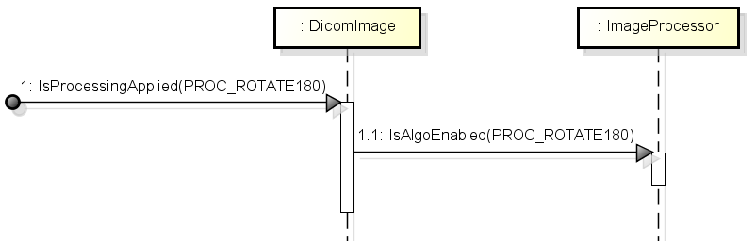

Is <Algo> Applied (cont.)
The new style

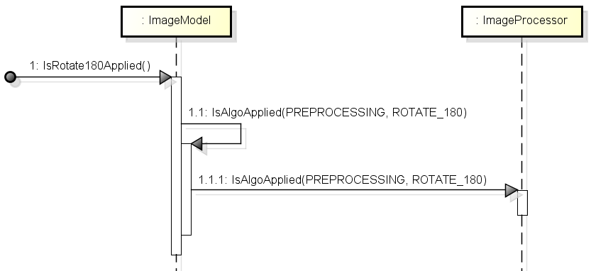
Image Model Methods
The class providing processing methods to the client should be ImageModel instead of DicomImage.
And the methods should be easy to use.

General Idea

bool Is<Algo>Available() const;
bool Is<Algo>Applied() const;
bool Apply<Algo>(bool apply[, int param], bool notify);

Image Model Methods (cont.)

Mirror
bool IsMirrorAvailable() const;
bool IsMirrorApplied() const;
bool ApplyMirror(bool apply, bool notify);

Emboss filter
bool IsEmbossFilterAvailable() const;
bool IsEmbossFilterApplied() const;
bool ApplyEmbossFilter(bool apply, bool notify);

Color
bool IsColorsAlgoAvailable(AlgoId algo_id) const;
bool IsColorsAlgoApplied(AlgoId algo_id) const;
bool ApplyColorsAlgo(AlgoId algo_id, bool apply, int param, bool notify);

Model View
The old style
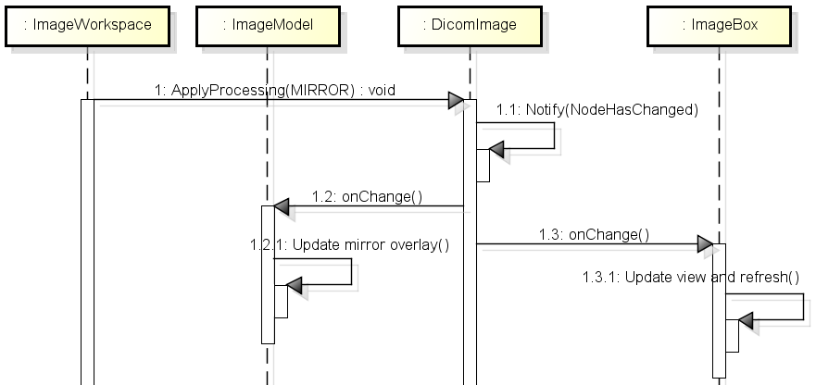

Model View (cont.)
The new style
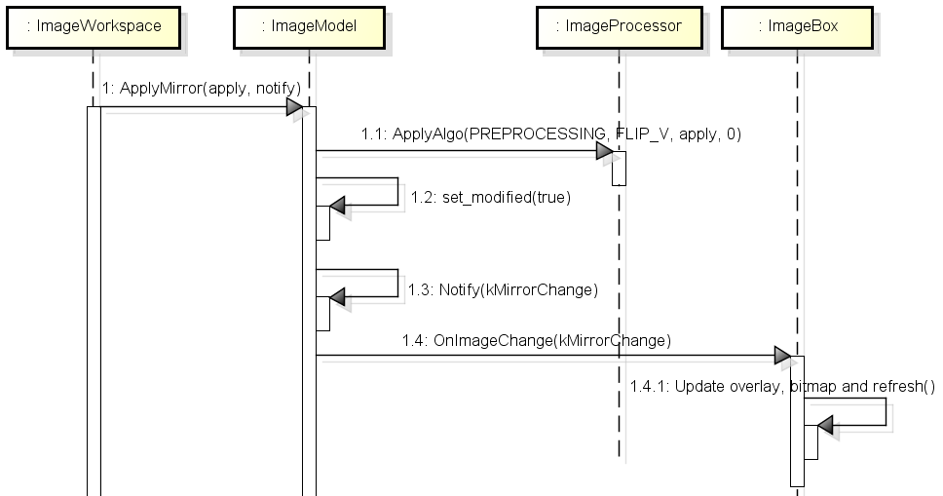
The Annotation Listeners
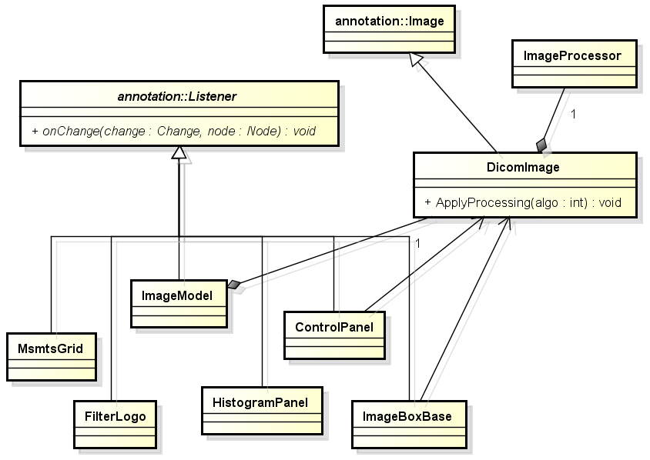
Image Listener
Derive from this class to listen to image changes from image model.

class ImageListener {
public:
virtual ~ImageListener();

virtual void OnImageChange(int change) = 0;

void AddImage(ImageModel* image_model);
void RemoveImage(ImageModel* image_model);

private:
// Listening image models.
std::set<ImageModel*> image_models_;
};

Image Listener (cont.)
Image changes

class ImageModel {
enum ChangeType {
kLoaded = 0, // 举loading animation的例子
kSaved,
kInfoChange, // Tooth numbers, acq date, etc.
kCalibrationChange,
kMirrorChange,
kRotate90rChange, // 为什么区分两种rotate？
kRotate180Change,
kCropChange,
kProcessingChange, // 还可以再细分
kPseudo3DChange,
kRefreshChange, // Let views to refresh.
};
};
Image Processor
ImageProcessor provides a minimal wrapper for Processing 2D SDK.

No GetImageType, GetFamilyString or GetSubFamilyString.

std::string ImageProcessor::GetImageType() const {
if (!IsDllOk()) {
return "";
}
const char* const image_type = GetStringValue(IMAGEINFO_TYPE);
return image_type == NULL ? "" : image_type;
}

No IsMirrorAvailable, IsMirrorApplied or ApplyMirror.

Change int to bool for return value, combine width/height to wxSize. Use wxString for input file path instead of const char*.

Image Show & Move
Show and Move shouldn't be methods of ImageBox.

Show
bool ImageBoxBase::Show(bool show = true) {
if (image_window_ != NULL) {
return image_window_->Show(show);
} else {
return wxWindow::Show(show);
}
}

bool ImageBoxBase::ShowSelf(bool show = true) {
return wxWindow::Show(show);
}

Image Show & Move (cont.)

Move
void ImageBoxBase::Move(const wxRect& rect, bool show) {
ImageWindow* image_window = dynamic_cast<ImageWindow*>(image_window_);
if (image_window == NULL) {
return;
}
...
}

void ImageBoxBase::Move(const wxPoint& pt) {
ImageWindow* imgWnd = dynamic_cast<ImageWindow*>(image_window());
if (NULL != imgWnd) {
return imgWnd->Move(pt);
} else {
return wxWindow::Move(pt);
}
}
Image Show & Move (cont.)
The old style
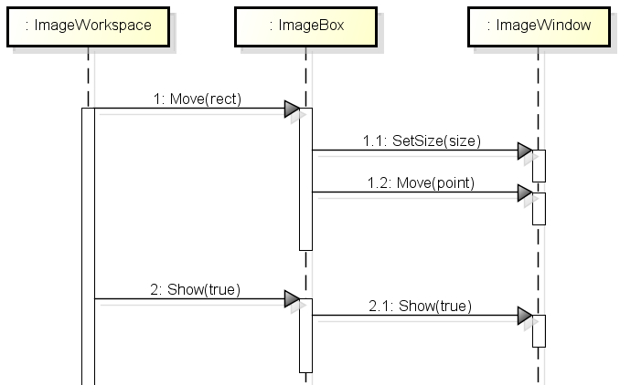
Image Show & Move (cont.)
The new style
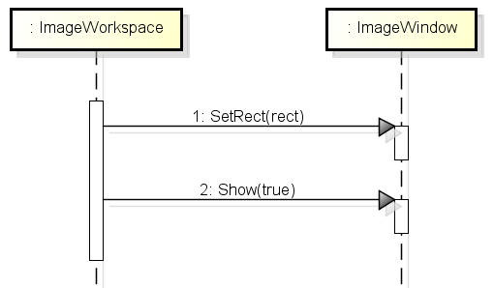

Inside Looking Out
Inside looking out is NOT a model property.
And general XML shouldn't care about "mirrortoolstatus".

The old style
class ImageModel {
private:
bool inside_looking_out_;
bool mirror_tool_status_;
};

bool ImageModel::GetMirrorStatus() {
bool bInsideLookingOut = inside_looking_out_ && CanApplyInsideLookingOut();

return mirror_tool_status_^bInsideLookingOut;
}

Inside Looking Out (cont.)
The new style

class ImageBoxBase {
private:
bool inside_looking_out_;
};

void ImageBoxBase::UpdateCanvasMirror() {
m_canvas->setMirror(image_model_->IsMirrorApplied() ^ GetInsideLookingOut());
}

void ImageBoxBase::HandlePaint(...) {
if (GetInsideLookingOut()) {
wxImage image = bitmap_.ConvertToImage().Mirror();
dc.DrawBitmap(wxBitmap(image), x, y, false);
}

